**Project Description: Analysis of viscosity values of different biomass slurries sourced from biomass throughout the Southeastern United States of America.**

1. **Abstract**

This project aims to determine the most viable biomass feedstock for biomass slurries used in sub-surface fracture injection as a means for carbon capture. The methodology will include graphical analysis to determine the roundest particles and the lowest slurry viscosity. There will also be cost analyses ran and feasibility studies to support determination of feedstocks. Correlations will be drawn to determine how all of the variables align in determining the proper biomass candidate for a large scale carbon capture project. The initial findings indicate that the feedstock with the roundest and smallest particle sizes will produce the lowest viscosities and therefore will be the most efficient biomass feedstock.

1. **Background**

The importance of reducing viscosity in biomass slurries lies entirely in the economic feasibility of biomass related projects. In this particular case, we intend to reduce the viscosity of biomass slurries for more efficient sub-surface fracture injection as a means for carbon capture in order to turn a profit and negate the costly requirements for transportation and pretreatment. In many applications such as the biofuels industry, higher viscosities can significantly impair the efficiency of its conversion into a usable fuel source. Many of these complications arise in the pumping and spraying aspects of the industry(Kuznetsov et al., 2021). One of the components that significantly reduces viscosity is reduction of particle size and analysis of roundness and spherical characteristics. Such examples have been cited in works relating to enzymatic hydrolysis of biomass slurries where it was determined that reducing particle size directly corresponded to lower viscosities(Dasari & Berson, 2007). The significance of such reductions has significant economic implications throughout multiple industries via increased solid loading and lower energy requirements in transport and conversion. This study aims to determine which biomass feedstock from the Southeastern United States can most effectively be used in carbon capture and the current energy transition.

1. **Aims and Implications**

The main goal of this project is to identify a biomass feedstock that currently serves as a waste product releasing carbon-based gases into the atmosphere that can readily be utilized for slurries as a means of carbon capture. The identification of a biomass slurry with a low viscosity with minimal to no pretreatment has much broader implications than those for carbon capture. Low viscosity slurries reduce the amount of energy required to transport, pump, and convert biomass, which in turn can increase the energy return on investment for biofuels, bioplastics, and other biomass related industries. This study aims to compare through regression analysis, correlation coefficients, graphical analysis, and literature review, how the energy return on investment of a biomass slurry project can be increased. The project is highly dependent on particle size analysis using Wadell’s roundness coefficient(Cruz-Matías et al., 2019) which has been directly linked in previous studies to the pumpability of slurries (Elliott et al., 2015). By comparing the roundness coefficients we can identify biomass and treatments that can be most efficiently pumped. The overarching goal will be to take these determinations and compare them to values derived from literature, and cross referenced with biomass assays throughout the southeast to identify the most effective biomass feedstock for our carbon capture project. The initial hypothesis is that the feedstock that produces the smallest and roundest particles will produce the lowest viscosity.

1. **Methods**

The first method of measurement will be to utilize a small <0.1g sample of the milled biomass feedstock. We will pass it through a 300-micrometer sieve and then take that sample and pass it under a microscope. From there we will take four measurements on each particle and sort them smallest to largest, using a sample size of 20 particles. Using these measurements, we can calculate Wadell’s roundness coefficient for each particle. Next will be to create histograms for each biomass feedstock and their treatment, for example Pine Chips treated using pyrolysis at 250°C for 1 hour with 5g of Lignosulfonic Sodium Salt Acid. Next begins the correlation coefficient calculations to determine if there is a correlation with the treatment type and the roundness values. We will also take the control samples of each biomass feedstock and run a linear regression analysis to determine which biomass feedstock produces the roundest particle sizes. Furthermore, we will take the mean values of particle sizes for all treatments and feedstocks and determine which variable produces the smallest particle size and cross reference that with the roundness values to determine the most viable feedstock candidate.

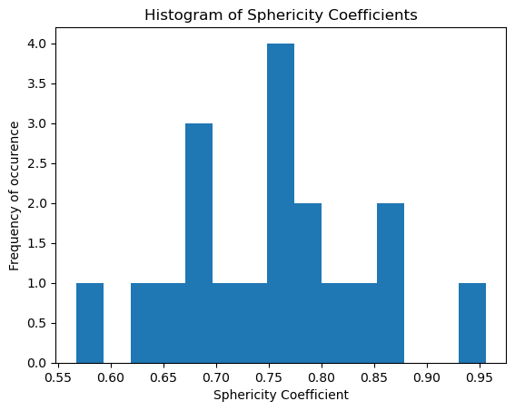

*Figure 1. Wadell Roundness Coefficient Histogram for analysis of pumpability of a single biomass feedstock*

Next, using values from previous projects measuring viscosity, we will run graphical analyses to determine which biomass feedstock has the lowest measured viscosity. Finally, we will run data through a cost analysis function that will take into account abundance of the biomass and the viscosity characteristics to determine the most feasible feedstock candidate. The final product will then be a map displaying the locations of the most viable biomass feedstock throughout the Southeastern United States along with graphics of our measured results.

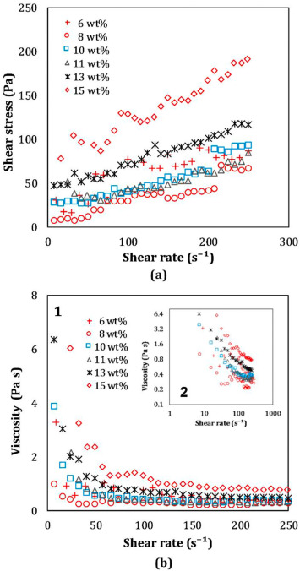

*Figure 2. Example of the viscosity graphs that will be created to analyze the lowest viscosity values and the feedstock that produces it.*

*Source:* (Faghani et al., 2020)

1. **Timeline**

November 3-16: finish calculation of roundness coefficients and particle size analyses of different feedstocks.

November 18-20: Find viscosity values from previous projects

November 21-23: Finalize Graphics of values

November 24-30: Finalize calculations and statistics

December 1-10: Generate final report and organize graphics and statistics in appropriate and aesthetic manner.

1. **Bibliography**

Cruz-Matías, I., Ayala, D., Hiller, D., Gutsch, S., Zacharias, M., Estradé, S., & Peiró, F. (2019). Sphericity and roundness computation for particles using the extreme vertices model. *Journal of Computational Science*, *30*, 28–40. https://doi.org/10.1016/j.jocs.2018.11.005

Dasari, R. K., & Berson, R. E. (2007). The Effect of Particle Size on Hydrolysis Reaction Rates and Rheological Properties in Cellulosic Slurries. In J. R. Mielenz, K. T. Klasson, W. S. Adney, & J. D. McMillan (Eds.), *Applied Biochemistry and Biotecnology: The Twenty-Eighth Symposium Proceedings of the Twenty-Eight Symposium on Biotechnology for Fuels and Chemicals Held April 30–May 3, 2006, in Nashville, Tennessee* (pp. 289–299). Humana Press. https://doi.org/10.1007/978-1-60327-181-3_26

Elliott, D. C., Biller, P., Ross, A. B., Schmidt, A. J., & Jones, S. B. (2015). Hydrothermal liquefaction of biomass: Developments from batch to continuous process. *Bioresource Technology*, *178*, 147–156. https://doi.org/10.1016/j.biortech.2014.09.132

Faghani, A., Sen, S., Vaezi, M., & Kumar, A. (2020). Rheology of fibre suspension flows in the pipeline hydro-transport of biomass feedstock. *Biosystems Engineering*, *200*, 284–297. https://doi.org/10.1016/j.biosystemseng.2020.10.009

Kuznetsov, G. V., Romanov, D. S., Vershinina, K. Yu., & Strizhak, P. A. (2021). Rheological characteristics and stability of fuel slurries based on coal processing waste, biomass and used oil. *Fuel*, *302*, 121203. https://doi.org/10.1016/j.fuel.2021.121203